Portfolio ACL Paper Summary

**Paper Title:**

U.S. State-Level Policies by Extracting Winners and Losers from Legislative Texts

**Paper Authors and Affiliations:**

Maryam Davoodi – Purdue University – looks to be a graduate research assistant

Eric Waltenburg – Purdue University – looks to be a political science professor

Dan Goldwasser – Purdue University – looks to be a computer science professor

**Problem Addressed by Paper:**

The paper argued that, even though state-level policy decisions have a significant and long-lasting impact on everyday lives, we know very little about how the policy decisions are made in the legislative process. In this paper, the authors try resolve this lack of understanding by looking at the impact of policy decisions on relevant stakeholders using NLP to have an insight on the legislators’ decision-making process.

**Prior Work:**

The authors claim that recent NLP architectures can provide new understanding of state-level legislative efforts by better representing policies within states and across states. However, they emphasize that prior work focuses on analysis on legislative bills using traditional techniques, and, although some of the state-level did a good job of predicting the progression of state bills in the legislative process, they judge policies in those bills using a limited context and cross-state patterns are not taken into consideration.

The authors’ work was inspired from previous roll-call classification work that predicted voting likelihood, bill text classification work that predicted whether a bill comes out from a standing committee based on the bill’s text, urgency of the solved problem in the bill, and the sponsors, winners-losers analysis work that analyzed the impact of bills on its stakeholders, work to analyze affect of legislators’ demographic backgrounds on roll-call voting and here the authors previously built a graph to predict such voting groups, and some works involving graph embedding in NLP.

**Unique Contributions:**

When analyzing state legislation, this paper uses a data-driven approach by looking at the stakeholders that are the winners and losers of the bills. They argue that the analysis of the winners and losers can clarify the state-level legislative efforts and can build cross-state patterns through the common stakeholders that are affected by the state bills being analyzed by the model. The authors claimed that the idea of winners and losers can create a new category of NLP models for predicting legislators’ individual voting behaviors. The authors’ work extends previous winners-losers analysis studies and creates the first automated framework for the analysis of stakeholders on state bills.

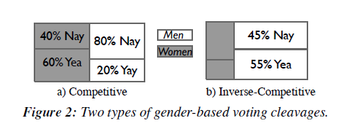

The political science community likes to predict voting groups based on the ideological and demographic identities of legislators. These diverse identities split legislators into groups. The authors are measuring the amount of consensus within and across these groups using classification. For a given identity, like gender or political party, the paper says that a bill is competitive if the majority vote of legislators from a group is different from that of the opposite group, and a bill is inverse-competitive if there is a tie in votes of legislators from the same group. In Figure 2a above from the paper, the bill is shown to be competitive by gender with women clearly opposing and men clearly for the bill. In Figure 2b from the paper, the bill is shown to be inverse-competitive by gender since there is a near tie in votes from the men.

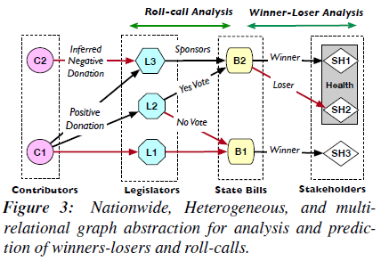

The framework proposed in this paper is as follows. The authors designed a crowd-sourcing pipeline to extract and analyze winners and losers (stakeholders) of state bills and form a new annotated dataset. Next, to automate the winners-losers analysis, they created a nationwide graph abstraction to model the state legislative process and a joint text and graph embedding architecture for predicting winners and losers. Figure 3 above from the paper shows a sample of their graph abstraction. Their model captures the interactions of different bills, stakeholders, legislators, and money donors while maintaining dependencies between their textual attributes. They use a relational graph convolutional network to represent the different relationships. They use a RoBERTa transformer after doing domain-adaptive pretraining on political texts using the Masked Language Model task. Finally, they utilize their roll-call analysis, winners-losers analysis, and prediction model to decipher the voting behavior of the state legislators.

**How Authors Evaluated Their Work:**

20% of the bills was used for testing. They used macro F1 as their evaluation metric over accuracy since their data was highly skewed. They built variations of text-based models with logistic regression classifier, three graph-based models, and three naïve models that act as baseline models to compare with their joint text-graph model.

Next, they compared the performance of their baseline models with the joint text-graph model in determining bill survival with unknown, known, and predicted winners or losers.

**Conclusion:**

The combination of their graph abstraction that shows the interactions between the relevant legislative parties and their prediction architecture that predicts winners and losers of bills and votes on them is very useful in determining the impact of policy decisions of state-level bills and will enable the public to have an insight to what going on or what are the contributing decision factors on the voting decisions of the state bills. Their work was very thoughtful and, in my opinion, made very good use out of current NLP techniques and previous works. In the future, works like these can be used by the public to clarify the legislative process, state or national level, and it can be used to determine which state to relocate based on their views.

**Number of Citations Received:**

According to Google Scholar, this paper was cited only 1 time.

**References**

[1] Davoodi, Maryam, Eric Waltenburg, and Dan Goldwasser. "Modeling US State-Level Policies by Extracting Winners and Losers from Legislative Texts." Proceedings of the 60th Annual Meeting of the Association for Computational Linguistics (Volume 1: Long Papers). 2022. <https://aclanthology.org/2022.acl-long.22/>